How to use the get to the Charactermancer:

1. Go to the campaign on Roll20 here: <https://app.roll20.net/join/12936785/ifBTxQ>
2. Launch the Game and click on the Journal tab and then the Character I created for you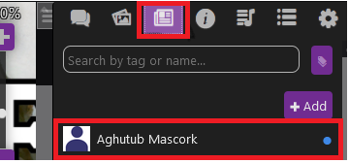
3. Click on the Character Sheet and then select the settings wheel:

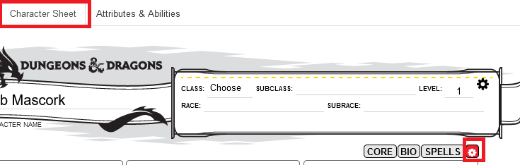

1. Scroll down and you’ll see both versions of the Charactermancer

